Profile for the position of
Australian Legal Officer
Sheltons Accountants UK
(based in London SW1)

Sheltons Accountants – Accountants & Business Advisers to internationally operating businesses

Opportunity to continue your career with us in our Sydney office

- Position

  - Legal Officer – Australian qualified solicitor
  - Reporting to a senior Australian qualified solicitor, and to the Managing Partner

- When and where

  - Commencement – January 2020 or ASAP thereafter
  - London SW1 (near London Victoria)

- Role

  - The following outlines the likely types of work, initially working in close collaboration with colleagues.

  - Providing a wide range of legal assistance on Australian law to UK-based businesses or their Australian-controlled entities. The client would be either the UK entity or the UK-owned Australian company
  - Drafting or reviewing a range of commercial agreements (such as lease agreements, distribution agreements, cost-plus agreements and so on) governed by the law of the Commonwealth of Australia or of one of the States of Australia (New South wales, Victoria, Tasmania, Queensland, South Australia and Western Australia)
  - Advising on and drafting documents relating to Australian employment law, ranging from drafting employment agreements to advice on redundancies, termination, employee rights, employers’ legal obligations and the like
  - Forming Australian companies, Australian company secretarial work, amending articles of association (constitution)
  - Advising on Australian work and business visas
  - Advice on and registering trademarks in Australia
  - Advice on and assisting with obtaining Australian domain names (especially ‘.com.au’)
  - Participating in virtual and face-to-face meetings with senior executives and their advisers where your role would be to provide off-the-cuff advice on Australian legal matters

  - The following outline the elements of the role other than the provision of legal assistance directly to the client:
  - Generally supporting your colleagues in serving clients
  - Some involvement in internal Sheltons Group matters, as pertains to our Australia office

- Professional characteristics

- It is essential that you

  - are currently an Australian qualified solicitor
  - have the right to work in the UK for at least 1-2 years
  - have an unlimited right to work in Australia
  - are currently (or have been) an Australian qualified solicitor practising with an Australian law firm, in Australia for at least three years over the past five years
  - have experience with all or almost all of the types of work listed under ‘Role’
  - have excellent IT skills
  - are able to command the respect of clients (especially UK and other Western European based clients) with your knowledge of Australia generally, including in the areas of business, economics and politics
  - have had significant experience in commercial and corporate law

- An advantage if:

  - you speak another major language
  - you have lived in a third country

- Personal characteristics

  - You are ambitious, self-motivated, energetic
  - You enjoy travel and have no problems travelling abroad
  - You are healthy, social, team-minded and outgoing

- About Sheltons

  - We have offices in Sydney, Copenhagen (since 1995), Malta, London – and soon Milan and other countries
  - You would be working mainly with clients of Sheltons Accountants Australia (Sheltons Australia)
  - Sheltons Australia, part of Sheltons Group, works exclusively with foreign businesses coming into Australia, mostly from Western countries
  - Sheltons Australia and Sheltons UK will soon commence assisting UK-based businesses investing abroad – including in Australia
  - Sheltons Australia will soon commence assisting UK-based businesses investing abroad – including in the UK
  - All clients of Sheltons are internationally operating
  - We cover a wide range of areas for our niche target group
  - Sheltons is an accounting and business advisory firm but is very strong in the area of international tax consulting; we also run courses around the world on international tax for tax advisers and in-house tax staff of MNCs
  - Sheltons Group is completely independent - with no formal links to any network of accounting, legal or other firms
  - Sheltons UK is located in modern, stylish, recently renovated offices in the Victoria (SW1) area of London
  - Sheltons Australia is located in modern offices in the Sydney CBD
  - See www.SheltonsGroup.com

- What we offer

  - Genuine opportunities for rapid advancement – and expansion of your areas of expertise
  - An exciting position with a small, dynamic, internationally-orientated firm
  - An opportunity to develop your skills and your network
  - A very international environment
  - Some overseas travel and substantial interaction with colleagues in offices abroad
  - Generous attitude towards taking leave without pay

Contact and applications

If this role sounds like you, please submit your cover letter and CV to:

Ms Courtney Gleeson at C.Gleeson@SheltonsGroup.com
LLB (Hons), B.Psy, GradDip LP
Legal Officer (Australian Qualified)

Detailed CVs and are very welcome; we also like to hear about your interests and hobbies and your non-work achievements.

Our London location

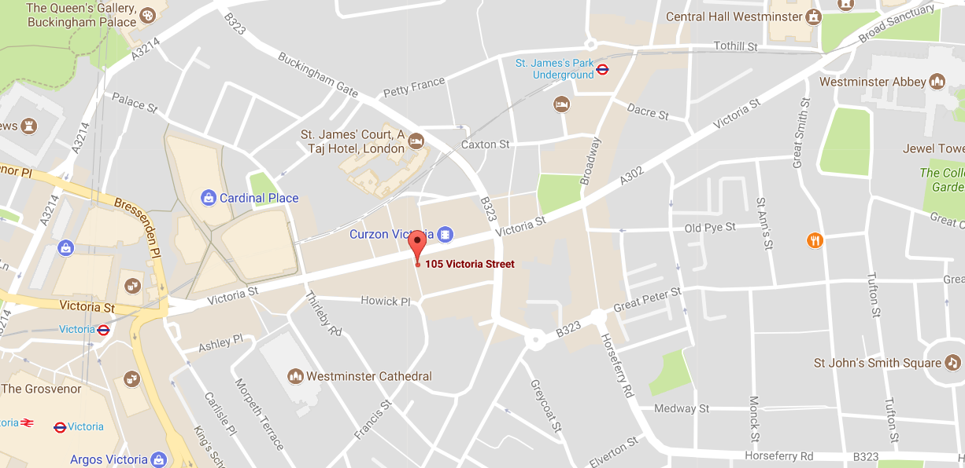

Appendix – what we offer

What we offer
the candidate for the position of
‘Legal Officer’
at Sheltons Accountants
(London, United Kingdom)

- Interaction with people and businesses from many countries

  - Sheltons Accountants UK work exclusively with foreign businesses
  - These are SMEs (and sometimes larger) from many countries, in particular from Australia, North America (especially the US) and Western Europe, investing in the UK
  - All our clients plan to do or are already doing business in or with the United Kingdom and range from those with substantial operating subsidiaries in the UK to those merely exporting or with just a single employee in the UK
  - Our clients operate in a wide range of business sectors
  - You will also liaise with existing colleagues in various countries – and be involved in setting up offices in other countries

- Variety of work – and choices

  - To begin with, you will be exposed to a substantial variety of work
  - You will interact with colleagues, suppliers and others based in several countries
  - Sheltons is a growing firm, with new clients and enquiries coming in every day
  - We plan to open offices in several larger countries in the near future
  - You would have the opportunity to grow rapidly with the firm
  - You would have the opportunity of working in one of our offices abroad

- An opportunity to significantly develop – and to develop many skills

  - You would not only be able to cultivate your current skills but we would assist you in developing new skills
  - We would actively assist in your development – with your work management, managerial skills, IT skills, etc
  - We are always very keen to assist our colleagues with external training

- A very international environment including some international travel

  - You would regularly work with your colleagues in our other offices
  - We expect to open at least 3-4 new offices in other countries in the next 2-3 years
  - Not only does the local office work as a team but the group works as a team and people from one office assist other offices in other countries.

- A position in a friendly team

  - Sheltons is a small but growing firm with a very professional but friendly working environment
  - As you develop, we would expect you to have a growing influence on managerial aspects of the office
  - You would join a well-functioning and pleasant team of colleagues - and you would be expected to make every effort to maintain that status

- A work location in modern offices in a central location (SW1)

  - Central. Our London office is located in SW1, in central London – next to St James Park, Buckingham Palace and Westminster, as well as a close walk to Victoria Station with access to over ground train services.
  - Modern. The London offices are newly established (in 2017); and have modern facilities.
  - Comfortable. We offer a very comfortable and ergonomically thoughtful working environment.
  - Lunch. Each Friday Sheltons cover lunch for all employees, the idea being to eat together outside the office.

