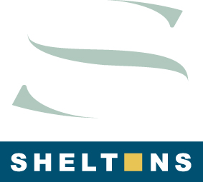

Doing Business in Denmark Guide

We are very pleased to announce that the ‘Doing Business in Denmark Guide’ was released on 19 December 2016. We at Sheltons are proud to be so involved with this publication.

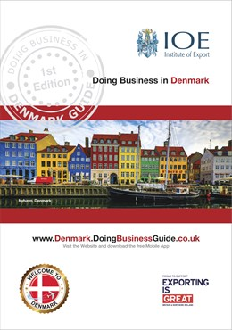

The guide is produced in conjunction with UK Institute of Export (IOE), Exporting is Great - Britain and Northern Ireland and the British Chamber of Commerce.

The guide is designed to provide basic knowledge about Denmark on many topics such as business culture, economy and the potential opportunities of doing business in or with Denmark.

Sheltons were chosen as the sole ‘market expert’ in the area ‘Accountant / Professional Business Services’.

The online guide website can be viewed via the following link: www.Denmark.DoingBusinessGuide.co.uk

The very impressive mobile app is available to download from the Google Play Store and Apple App Store, by simply searching ‘Doing Business Guides’.

The hard copy version of the Guide will be available in three weeks.

Please see www.sheltonsgroup.com/news/ for the official press release from the IOE

If you have any questions at all about Denmark or about the guide just let us know.

Accountants & Advisers to internationally operating businesses Local & International Tax Advisers
International Tax Training (Sheltons-SITTI) International Expat Relocation

DK@SheltonsGroup.com www.SheltonsGroup.com

