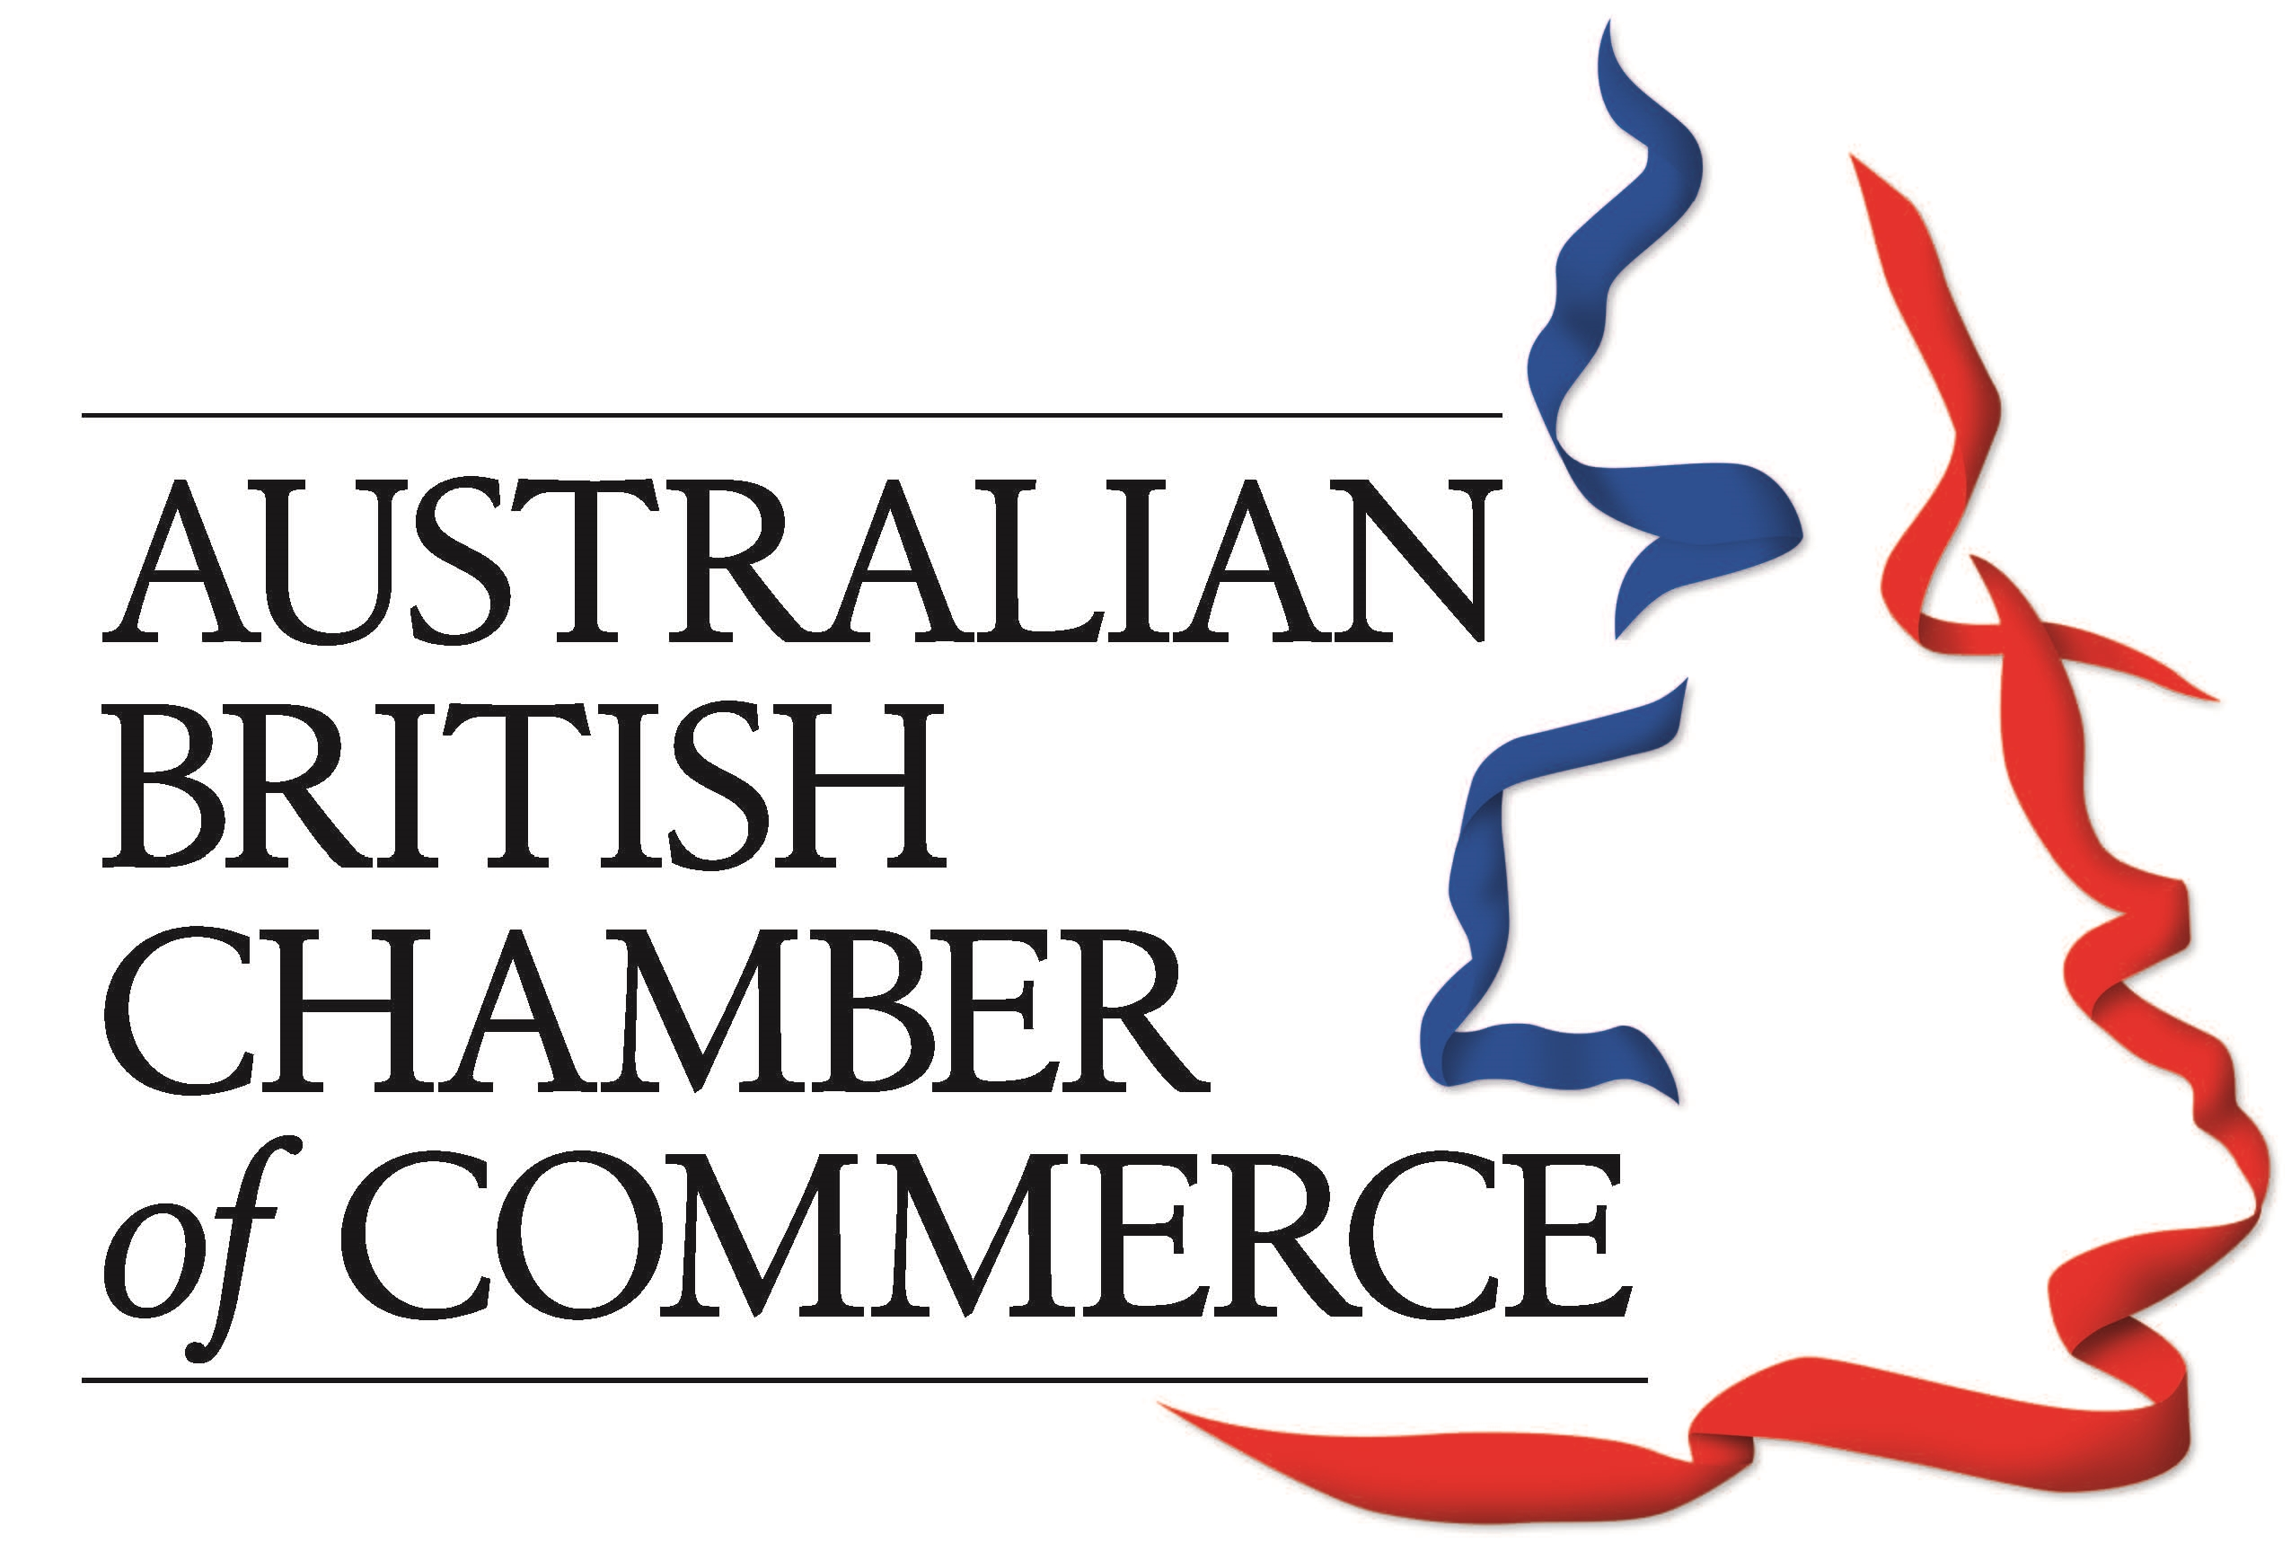
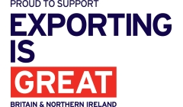


PRESS RELEASE

Date: 14th October 2016
For immediate release

Contact: Craig Smith – Project Director
Email: craig.smith@export.org.uk / Tel: +44 (0)1298 79562

‘Doing Business in Australia Guide’ launch

The ‘Doing Business in Australia Guide’ website is now live and the hard-copy brochures are currently being distributed.

14th October, 2016 – The ‘Doing Business in Australia Guide’ is now officially live and can be accessed via: www.Australia.DoingBusinessGuide.co.uk. The guide was successfully launched earlier this week at the IOE World Trade Summit, at Gresham College in London on Wednesday 12th October.

The main objective of this Doing Business in Australia Guide is to provide you with basic knowledge about Australia; an overview of its economy, business culture, potential opportunities and to identify the main issues associated with initial research, market entry, risk management and cultural and language issues. We do not pretend to provide all the answers in the guide, but novice exporters in particular will find it a useful starting point. Further assistance is available from the Department for International Trade (DIT) team in Australia. Full contact details are available in this guide.

To help your business succeed in Australia we have carefully selected a variety of essential service providers as ‘Market Experts’; Ashurst, AST Language Services, Bibby Financial Services, Farazad Investments, HSBC, Mott MacDonald, Regus Australia, Sheltons, SingTel Optus Pty Limited and Virgin Australia.

The guide has been produced by International Market Advisor, in partnership with the Institute of Export, and with support from the Australian British Chamber of Commerce and UK Export Finance.

Six things to know about exporting to Australia:

- Australia is the 5th largest economy in the Asia-Pacific region, and the 12th largest economy in the world. It has had 25 years of uninterrupted economic growth. Australia’s GDP per capita at current exchange rates make its citizens among the world’s top five wealthiest.
- There are more British citizens in Australia than in any other foreign country. 1.2 million Britons are permanent residents in Australia and over 600,000 visit every year.
- Australia’s exposure to, and engagement with, the fast-growing Asian region can help British companies looking to expand into this region. Seven out of Australia’s top ten trading partners are Asian countries. More than two million Australians (approximately 10% of the population) speak an Asian language at home.
- The 2018 Commonwealth Games will be held in the Gold Coast, Queensland, and will provide opportunities for UK businesses in areas of games infrastructure such as stadia, passenger rail and sports village facilities.
- The ‘National Broadband Network’ is the biggest infrastructure project in Australia’s history, costing A$35.7 billion. The project runs for the next eight to ten years and aims to deliver a fast broadband network to 95% of the Australian population. Opportunities for British companies will be in e-health, e-learning, digital entertainment and e-commerce for mobile.
- Australia is the leading location for Biotechnology in Asia-Pacific and the fourth largest biotech market in the world. Opportunities are widely available for British companies looking to market services in drug discovery, development, clinical trials and contract manufacturing. For biotechnology and pharmaceutical companies there are opportunities to partner with world-leading research institutions.

